Fall Semester 2013

Organic Chemistry I

Midterm Examination #2

Name (print):

Name (sign):

Recitation Instructor (name, day):

***Instructions***

1. Keep the exam closed until you are instructed to begin.

2. The exam consists of 7 questions. The first thing you should do is make

sure that no pages are missing. If a page is missing, notify a proctor

immediately

3. You will have 1 hour and 15 minutes. Questions are labeled from ‘easy’ (*) to

hard (****). Budget your time wisely.

4. Make sure to show all of your work, and this should fit

into the space provided. If you need to use the back of the paper, you must make note of it in the space provided for credit.

Good Luck!

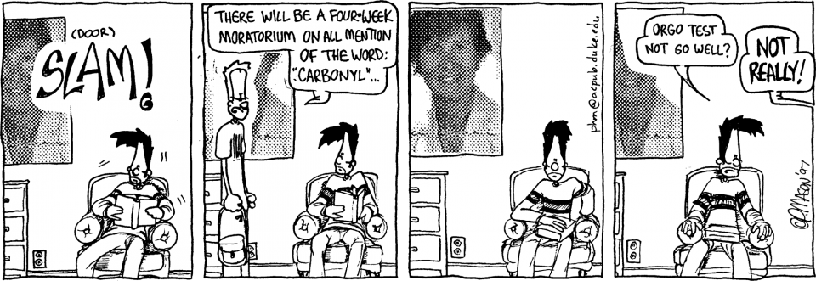1.____(15 points)

2.____(20 points)

3.____(12.5 points)

4.____(12.5 points)

5.____(10 points)

6.____(20 points)

7.____(10 points)

1a. Rank the following carbocation stability from *most stable(1)* to *least stable(4) and briefly explain your answer.* (5 points)*\**



*Explanation:*

1b. Provide a more specific name of the following carbonyls (ester, carboxylic acid, ketone, aldehyde, formaldehyde). Then rank them from *most reactive (1)* to *least reactive* *(4)*. (5 points)*

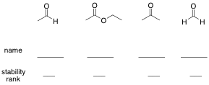

1c. Predict the relative acidity from *most acidic* (1) to *least acidic* (2) of the following O-H containing molecules and explain your answer, using structures were possible in support. (5 points)* *

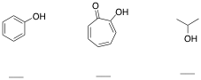

2. Mechanisms (20 points).

2a. Show the mechanism arrows for the following reaction. (5 points)*

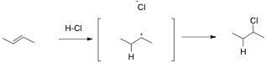

2b. Show a mechanism for the following reaction that explains the diastereoselectivity. (5 points)**



2c. Show a mechanism for the following reaction (5 points)***

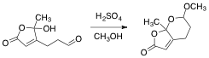

2d. Show a mechanism for the following reaction that explains the diastereoselectivity (5 points)****



3. Show the product(s) of the following reactions (12.5 points total, 2.5 points each)**











4. Show the reagent(s) necessary for the following reactions (12.5 points total, 2.5 points each)**











5. The following two alkenes could theoretically be converted into alkynes through a bromination/ double elimination sequence. Which one do you believe would work better/ faster, and explain your answer [use structures primarily, with a few words to help explain]. (10 points)***

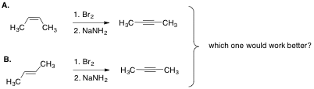

6. Synthesis Questions. Make sure to draw out all of your reagents and intermediates clearly and legibly. You may use as many steps as needed, but they can each be done in three steps or less (20 points)***

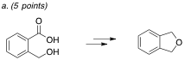

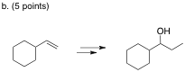

c. Propose a synthesis of 1-Hexyne using ethanol as your only carbon-containing starting material. (10 points)



7. One of the ways known to convert ketones into esters is a reaction known as a Baeyer-Villiger oxidation. The mechanism is analogous in many ways to the oxidation step of the hydroboration/oxidation reaction. Show a mechanism for both of these reactions, using the specific reactions illustrated below.****

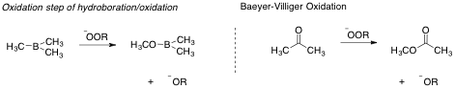

(A) Mechanism for the oxidation step of a hydroboration/oxidation (5 points).

(B) Mechanism for the Baeyer-Villiger reaction (5 points).